**CONTENT**

|  |  |  |
| --- | --- | --- |
| **S. no.** | **Topic name** | **Page no.** |
| **1.** | Adaptive Riesz Mean Filter | **2** |
| **2.** | Different Adaptive Modified Riesz Mean Filter | **5** |
| **3.** | Alpha Trimmed Mean Filter | **7** |
| **4.** | Geometric Mean Filter for Image Denoising | **9** |
| **5.** | Sector Rotation Filter | **11** |
| **6.** | Modified Median Filter | **15** |
| **7.** | Recursive Spline Interpolation Filter | **17** |
| **8.** | Basic Mean Filter | **19** |
| **9.** | Min/Max Filters | **21** |
| **10.** | Basic Median Filter | **23** |

**PARAMETERS USED**

|  |  |
| --- | --- |
| Filters | Parameters |
| **Adaptive Riesz Mean Filter** | =Pixel Singularity |
| **Different Adaptive Modified Riesz Mean Filter** | =Pixel Weight |
| **Alpha Trimmed Mean Filter** | (d, α)=Item trimming parameters  (α=d/2)  d=(1-mn)  (m,n)=Window dimensions |
| **Geometric Mean Filter for Image Denoising** | (m,n)=Window Dimensions |
| **Sector Rotation Filter** | m= Square window Size |
| **Modified Median Filter** | [dij]mxn**=**Binary Matrix of noisy image |
| **Recursive Spline Interpolation Filter** | m=Square window size |
| **Basic Mean Filter** | No Such Parameters |
| **Min/Max Filters** | No Such Parameters |
| **Basic Median Filter** | No Such Parameters |

**Adaptive Riesz Mean Filter**

**INTRODUCTION**

In this section, we introduce two linear spatial window filters designed for high density impulse noise the Adaptive Riesz mean Filter(ARmF) and the Different Adaptive Modified Riesz mean Filter(DAMRmF). They work on pixels of the image that have extreme values (i.e. 0 or 255).

The ARmF calculates a riesz mean of the mask window based on the pixel similarity of each pixel and replaces the noisy pixel. It has an adaptivity condition for a completely noisy window to prevent error in the results.

The DAMRmF works similar to the ARmF but uses a modified version of the Riesz Mean in its calculations and employs an adaptivity condition based on the Adaptive Median Filter.

**DETAIL**

**Adaptive Riesz mean Filter**

To apply filtering to the pixels at the edge of the image, we first pad the matrix symmetrically with the required number of pixels. The padded image matrix for an image is represented by where t is the number of pixels padded around the image.

To process the image, we have to determine which of the pixels are noisy. We define a binary matrix for that purpose. The binary matrix of image A is defined as where,

We define a window matrix for filtering as of size (2k+1) × (2k+1), where i and j are the indices of the pixel being processed and k is the number of pixels taken around it.

Adaptive Riesz mean Filter (ARmF) works with adaptive windowing i.e. it starts with a window size of 3×3 (for k=1) and increases the window size if all the entries in the window are considered noisy before processing it.

The filter works on the idea of a weighted mean filter in which the weight of each pixel is determined by the pixel similarity of the pixel to the center pixel. The pixel similarity between two pixels is defined as

For pixels that are closer to each other, the value of pixel similarity will be closer to 1. The mean calculated using this method is called the Riesz mean of the window.

Here, (s,t) is the set of all s and t such that is a non-noisy entry of and is the center pixel. The noisy center pixel is then replaced by the Riesz mean calculated this way.

**ALGORITHM:**

**Input:** noisy matrix,

**Output:** Denoised matrix,

Convert A from uint8 to double form

**For**

Compute the binary matrix

Compute and

**For**

**If**

**For**

**If**

**Break**

**End if**

**End for**

**End if**

**End for**

**End for**

**FLOWCHART: -**

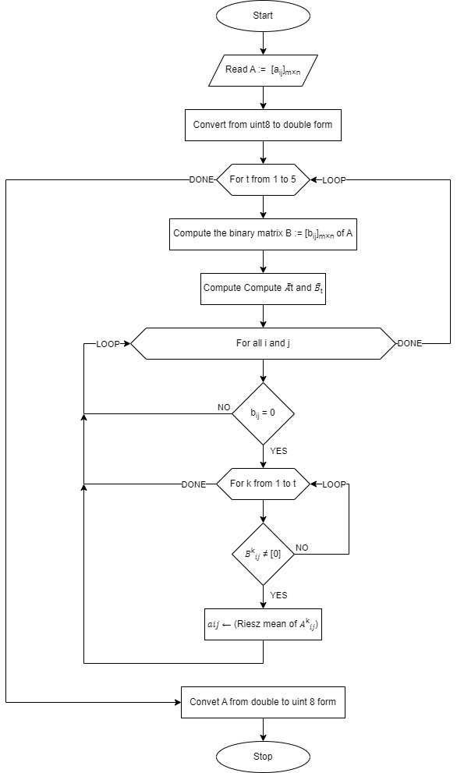

=Pixel Weight

**Different Adaptive Modified Riesz mean Filter:-**

The Different Adaptive Modified Riesz mean Filter works similar to the Adaptive Riesz Mean Filter explained in the previous section. The initial padding and finding of the noisy pixels is the same as ARmF. The adaptive window condition in this filter first checks whether the median of the window is noisy or not. If median is noisy, the algorithm keeps moving on to a larger window around the noisy pixel until the median is found non-noisy or the maximum window size is reached. If median is not noisy, we replace the center pixel with the Modified Riesz mean of the window explained below.This filter also works on weighted mean principal but here we change the pixel similarity factor with pixel weight defined below.

So the weight of every pixel in the mean is decided by its pixel weight with respect to the center pixel of the window . We call this mean the Modified Riesz mean.

Here, (s,t) is the set of all s and t such that is a non-noisy entry of and is the center pixel. The noisy center pixel is then replaced by the Modified Riesz mean calculated this way.

**ALGORITHM: -**

**Input:** noisy matrix, **Output:** Denoised matrix,

**Algorithm :-**

Convert A from uint8 to double form

**For**

Compute the binary matrix

Compute and

**For**

**If**

**For**

**If**

**Break**

**End if**

**End for**

**End if**

**End for**

**FLOWCHART: -**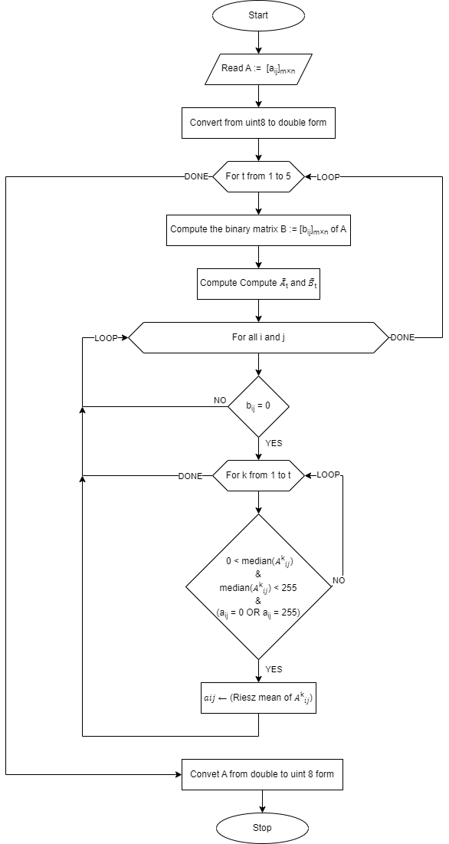

=Pixel Weight

**Alpha Trimmed Mean Filter for Image Denoising**

**Introduction:**

It is nonlinear windowed filter that uses the median and mean filters. The idea behind filter this is to look at the area around each pixel and remove the pixels that has the highest and lowest value , and use the remaining elements to get the mean value. The alpha parameter controls how many elements are removed.

**Background:**

The idea is to sort the items, select the first and last element out of the sort set, and then calculate the mean value using the remaining elements. For example below is the representation of how alpha trimmed mean is calculated

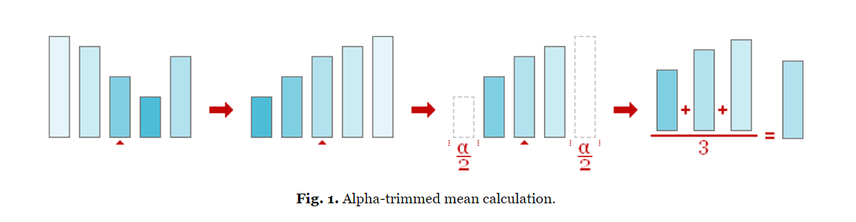

To obtain an alpha-trimmed mean,items are arranged in the ascending/descending order and elements from first and last are removed from the collection, and then mean of the remaining elements is taken.

The formula used here to calculate alpha trimmed mean for a given noisy pixel which is to be replaced with the calculated value:

f(x,y) =

**Where:**

**m,n :** Window dimensions

**d:** This parameter is used for calculating alpha trimmed mean which is equal to 2α

and α is the d/2 highest and d/2 lowest intensity values of the window array.

**∑g­r(s,t):** Summation of the remaining elements of the window array for finding the mean.

A few remarks concerning the **alpha parameter**, which controls item trimming. The number of elements that must be removed is referred to as alpha; in our filter**, d is 5** which means **α is 2.5** but we will be taking **α as 2** . As our filter is symmetric, one alpha is an even nonnegative integer smaller than the size of the filter window.

The alpha-trimmed mean filter degenerates into the mean filter when the alpha parameter's minimum value is 0. As alpha reaches its maximum value, which is equal to the filter window size minus one, the filter degenerates into a median filter.

**Algorithm:**

1. Window is placed over each pixel.
2. form a 1-D window array.
3. Sort the elements in the window array.
4. Elements are removed from front and at the back of the arranged set.
5. Calculate the mean of the remaining elements of the window array

Note: The widow dimensions can be 3x3,5x5,7x7 according to which value of d and α will change, but based on the observation 5X5 window gives the best result.

**Flow chart:**

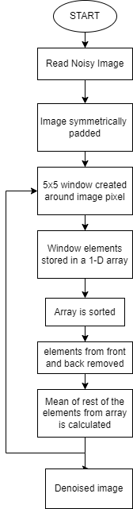

**Geometric Mean Filter for Image Denoising**

**Introduction**:

It is a type of image filter used to filter noises and smooth out images.The idea is to find the geometric mean of the window and replace the element with geometric mean. The geometric mean's output picture, G(x,y), is provided by

G(x,y)=[]**1/mn**

Where:

**G(x,y):** Calculated Geometric Mean which will be replaced with the center pixel of the selected window.

**m,n :** Window dimensions.

**Π**(**S(i,j)):** Product of Original Image Elements within

the selected window.

**Background:**

Geometric mean of the elements present in the geometric mean window is calculated and the center pixel of the window is replaced with result.The pixel (x,y) in the output image, for example, product of all 8 of the surrounding pixels raised to the 1/9 power is calculated when the window size is set to 3 by 3.

For instance, given below is a 3x3 window of the center pixel:

|  |  |  |
| --- | --- | --- |
| 5 | 16 | 22 |
| 6 | 3 | 18 |
| 12 | 3 | 15 |

Gives the result: (5*16*22*6*3*18*12*3*15)(1/9) = 8.77

The centre element of the widow (i.e 3 here) will get replaced with the above calculated value i.e 8.77.

**Algorithm:**

1. Read the noisy image.
2. Symmetrically pad the noisy image matrix.
3. Select the window size.
4. If window pixel ≠ 255 or 0 product of pixel value is stored in result array and element count is incremented.
5. Find the geometric mean of result array.
6. Replace the centre element of the window with calculated geometric mean.
7. Do it for all elements of the noisy image matrix.

**Note:** Noisy Image has been symmetrically padded for the smoothening of the edges. For a 3x3 window padding of 1 unit should be provided .It increases with the increase in the window size.

**Flow chart:**

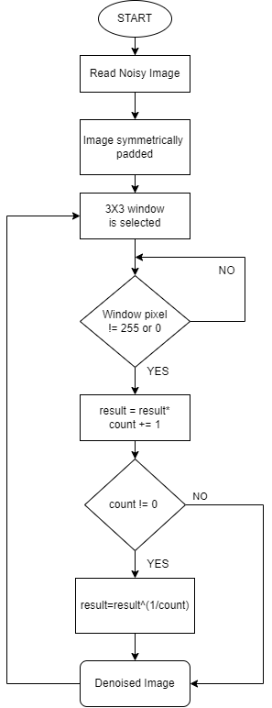

# Image Denoising based on Sector Rotation Filter

|  |
| --- |
| **INTRODUCTION: -**  Image processing is the process of removing noise pollution which is caused due to several environmental and equipment factors of image acquisition. These noise pollution cause interference to image processing. Different noises are added to the image to check the working of the filter and comparison is being made with the help of certain parameters. Image denoising with the help of standard median filter somewhat fails to clarify the borders of a noisy image and thus resulting the image becoming blurrier. Adaptive weighted median filtering algorithm, which uses a weighted operator to perform weighted operation on signal pixels, and then calculates the median value as the output. The weighted operation improved the noise filtering, but the output edges remain poor with the complexity being increased to the basic algo. Further on certain algorithms were developed and filtering effect on low density noise has been improved till some extent. However, when there are more extreme points in the selected window, the value of blurred coefficient and fuzzy variables are poor so the output image with high pollution degree is low. So, to fulfil this fault, an algorithm is developed to increase the window size variably according to the noise found on the sector of the window selected of the image. In this filter, the value of center point in different directions is calculated to evaluate the correlation according to separate values and the higher correlation points are taken in the result.  **IMPROVEMENT IN THE ALGORITHM: -**  Median filter denoised every pixel in the selected window. Median value of the window is selected to replace it with the center value. Low difference in the value of original center value to the calculated value still maintains the image details but if the difference is larger the details get destroyed. This is because the median value is not regular in an image and whether there is noise or not, every pixel is consecutively filtered which causes damage to the image. The filter effect become worse with image with high density noise.  To overcome this defect, extreme value of the gray value in the window is observed first. The extreme value of the gray value in the window, then the center pixel point has been polluted and the filtering operation is required. If it is not, then extreme value is not noisy hence the output is carried out directly.  Thus, for image with low noise density, window of lesser dimension would work significantly better than the one with higher dimension. The rotation rule for a window of 5x5 window is shown below. |
| A, B, C, D, E, F, G and H are the eight difference points. Except for the central pixel point, if the difference point is the extreme value of gray value in the window, the difference point is discarded, and the other difference points are calculated for the difference value in the sector region. The fan region with a small difference indicates a high correlation with the pixel value of the unpolluted center. If all the difference points are found at extreme values, then the noise density is higher, hence a window of significantly higher dimension is selected. Figure below shows an example of such case with expansion of window. |

If the same condition is found which lead to expansion of window size is the above condition, then the same would be applied here as well and a window of higher dimension will be selected.

Formulate the value of difference in the 8-difference point in the fan selected in the window.

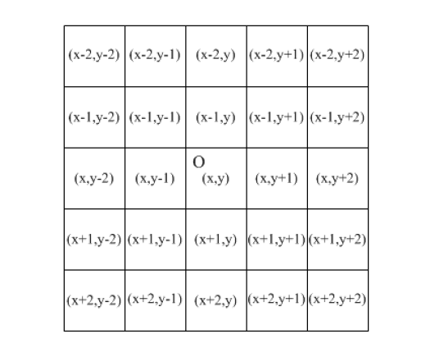

a(x-1, y) = 2*f(x-1,y) – f(x-2,y) – f(x-1,y+1)

b(x-1, y+1) = 2*f(x-1,y) – f(x-2,y) – f(x-1,y+1)

c(x, y+1) = 2*f(x-1,y) – f(x-2,y) – f(x-1,y+1)

d(x+1, y+1) = 2*f(x-1,y) – f(x-2,y) – f(x-1,y+1)

e(x+1, y) = 2*f(x-1,y) – f(x-2,y) – f(x-1,y+1)

f(x+1, y-1) = 2*f(x-1,y) – f(x-2,y) – f(x-1,y+1)

g(x, y-1) = 2*f(x-1,y) – f(x-2,y) – f(x-1,y+1)

h(x-1, y-1) = 2*f(x-1,y) – f(x-2,y) – f(x-1,y+1)

When there are more noise points in the sector, the grey difference of the sector must be larger, when there are few or no noise points in the sector, the grey difference of the sector must be small. When there is no noise in the sector region and it is in the grayscale flat region, the grayscale difference of this region must be very small, indicating that the correlation between the central noise point and this region is the highest. In this case, the median value of this sector region is taken instead of the grayscale value of the central noise point as output, which can better restore the image details.

**ALGORITHM: -**

1. Read the noise image matrix.
2. The center point of the filtering window is firstly tested for its extreme value. If the center point is not the extreme value of the pixel value in the window, the signal point directly outputs the pixel value of the center point.
3. Take the center pixel point as the center and take the 5×5 window to perform sector rotation filtering.
4. If the eight difference points do not meet the filtering conditions, step (3) is performed. At this time, it means that the image pollution is relatively serious, and filtering needs to be carried out by increasing the window.
5. If the difference point does not meet the filtering condition, then continue to increase the filtering window and repeat this step for filtering.
6. If it increases to the maximum window (above 13×13 window), it means that the pollution is very serious currently, and the median value in the filtering window is directly calculated for output.
7. Sum the output pixel points without filtering operation and the output pixel points after filtering operation to obtain a complete restored image.

**FLOWCHART**: -

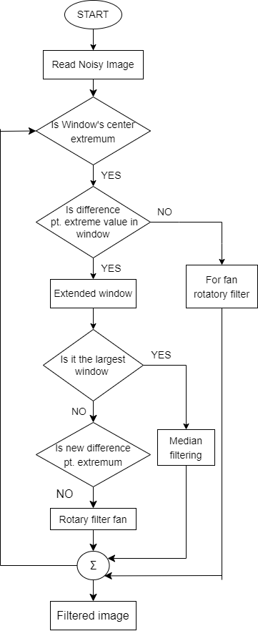

# Modified Median Filter

|  |
| --- |
| **INTRODUCTION: -**  An image is a composition of squared pixels arranged in row and column. It is captured by capturing devices like camera or scanner and stored in the mass storage of the computer system. A captured image is subjected to many kinds of distortion during the stages of processing, storing, compressing, transmitting and others. During the transfer of the image, noise may be added along the actual information. The unwanted information that added along the required information is due to certain environmental variations and faulty locations during transfer.  To answer the problems on this digital modern age, image processing is one of the most useful techniques for computer algorithms wherein these algorithms are used to perform the processing on digital images and some function to extract some important data from the image. Analog and digital image processing are the two methods used in image processing. Analog image processing is used for hardcopies like printouts and photographs while digital image processing technique helps to manipulate digital images with the help of a computer. There are three primary groups in image processing, composed of image compress, enhance, and restore and measurement extraction. One of the advantages of median filtering is that it can eliminate the effect of input noise values with very large magnitudes.  Median Filter decreases noise from an image without edge destruction and blurring but the drawback of this filtering technique is the performance which will be degraded in a high density of noise. Median filtering removes impulse noise by windowing the noisy image. In this study, the noise density of the image was identified and will be the basis of window sizes to be used in median filtering. The filtered image, using the proposed modified median filtering, will be the input to the recognizer, thus this study.  **ALGORITHM: -**   1. Read the noise image matrix A = [aij]XxY, where {x,y} >1. 2. Write the binary matrix D = [dij]mxn of A. 3. Write Pc and Pd. 4. For all i and j. If dij=1, then keep value of aij else Dij!=[0] then 5. Find value of Rij for Aij. 6. Evaluate the median of Rij. 7. Replace this value to the cij else keep the value of aij.   **FLOWCHART: -** |

**Recursive Cubic Spline Interpolation Filter for Image Denoising**

**Introduction:**

Interpolation is defined as a technique to derive an equation with the help of given constant discrete points. For any higher order function defined over a range [x,y], this method can used to generate a lower order function. The more the data points are available to interpolate, the more accurate lower order function can be generated. The points/ data are connected through a smooth curve, which is being utilized by cubic spline interpolation filter.

**Background:**

The filter is being used to remove Impulse noise. Basic idea behind this filter is to use the interpolation technique over the know noisy pixel. The filter would check each pixel to be either noise i.e. having a value of either 0 or 255, if it does it would take a 3x3 window around it, apply the interpolation method to give out the most accurate pixel value it is supposed to have. If the pixel is not found out to be noisy it would simply ignore it and move to next pixel.

**Algorithm:**

1. Read the noisy image.
2. Symmetrically pad the noisy image matrix.
3. If the pixel is not noisy move to next pixel
4. If the pixel is noisy, Select a 3x3 window around the noisy image
   1. If all the images are noisy in the 3x3 matrix take the mean value of the matrix
   2. if not, ignore all the other noisy pixel present in the 3x3 matrix and apply the cubic spline interpolation on it
   3. replace the generated value with the noisy pixel
5. Do it for all elements of the noisy image matrix.

Note: Noisy Image has been symmetrically padded for the smoothening of the edges. For a 3x3 window padding of 1 unit should be provided .It increases with the increase in the window size.

**Flow Chart:**

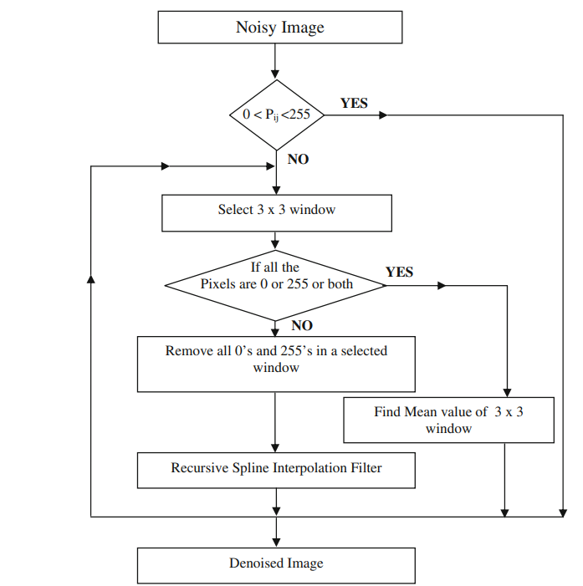

* Pi,j : It refers to the pixel value at location (i,j) of the matrix

**Basic Mean Filter for Image Denoising**

**Introduction:**

The basic mean filter is a type of image filter used to smear out noise and smooth out images. It is based on the algebraic mean in mathematics. The algebraic mean's output picture, f(x,y), is provided by

f(x,y)=

Where:

**f(x,y):** Calculated Algebraic Mean which will be replaced with the center pixel of the selected window.

**m,n :** Window dimensions.

∑**g(s,t):** Sum of Original Image Elements within the selected window.

**Background:**

The filter is defined to remove impulse noise. The filter iterates over symmetrically padded matrix, to check for pixels having a value impulse noise. If it does it would take a 3x3 window across it, find the mean of the window and replace the noisy pixel with the generated mean value. If the pixel is not found out to be noisy to be noisy it would simply move to the next pixel.

For instance, given below is a 3x3 window of the center pixel:

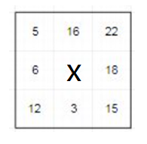  
Here the centre pixel is noisy.  
Replacing the centre pixel with the mean for the window

Gives the result: (5+16+22+6+3+18+12+3+15)/8= 12.5  
since we would be operating in uint8, it would convert 12.5 to 13, and hence the centre pixel would be replaced by 13.

**Algorithm:**

1. Read the noisy image.
2. Symmetrically pad the noisy image matrix.
3. If the pixel is not noisy move to next pixel
4. If the pixel is noisy, Select a 3x3 window around the noisy image
   1. apply the mean filter on it and obtain algebraic mean of the 3x3 window
   2. replace the generated value with the noisy pixel
5. Do it for all elements of the noisy image matrix.

Note: Noisy Image has been symmetrically padded for the smoothening of the edges. For a 3x3 window padding of 1 unit should be provided .It increases with the increase in the window size.

**Flow chart:**

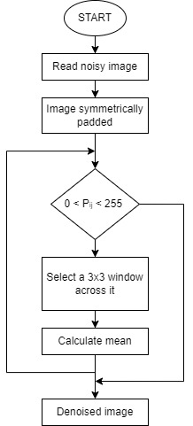

* Pi,j : It refers to the pixel value at location (i,j) of the matrix

**Min/Max filters for Image Denoising**

**Introduction:**

The Min-Max filter is a morphological filter which can be utilised for image denoising. Max and Min filter are used to process image data in spatial domain. Furthermore, they belong among [order-statistic filters](https://epochabuse.com/category/c-tutorial/c-image-processing-c-tutorial/image-restoration-and-reconstruction/order-statistic-filters/) along with filter. It is a non-linear filter that, within a predetermined window size, replaces each pixel in an image with the lowest or maximum value of its neighbors’ pixels. The smooth borders of the picture are successfully tracked by the min-max filter, and the smooth regions are successfully tracked by their average.

Formula used for calculating above-described pixel values:

f(x,y) =

f(x,y) =

**For Max filter:**

**f(x,y):** Maximum value of the pixel present the selected window.

**g(s,t):** pixel intensity values of the selected window.

**For Min filter:**

**f(x,y):** Minimum value of the pixels present the selected window.

**g(s,t):** pixel intensity values of the selected window.

**Background:**

In Min/Max filter first a window is selected. Window size can be 3x3,5x5,7x7.. etc not necessarily the larger the window size the better the output cause it depends on how noisy the image is. In both Min/Max filter first 0 and 255 pixel values are eliminated from the window this made the filter to work on combination of salt & pepper noise rather than individual salt noise and pepper noise because in case of Max filter, the centre pixel will now get replaced with the maximum pixel value of the window which is not 255 thus preventing the image from becoming totally white, similarly for Min filter this prevents the image from becoming totally black

**Algorithm:**

1. Read the noisy image.
2. Pad the image symmetrically.
3. Select the window.
4. Remove the 0 and 255 pixel values from the selected window.
5. (A) For Max filter: Find the maximum pixel value from the window.

(B) For Min filter: Find the minimum pixel value from the window.

1. Replace the center pixel value of the window from the calculated Min/Max value.

**Flow chart:**

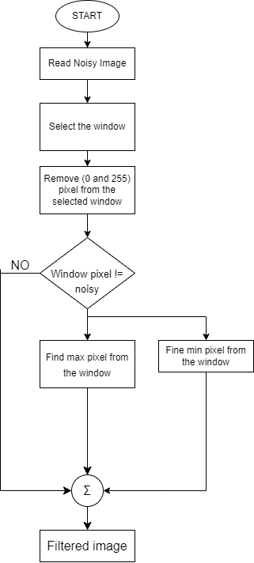

**Basic Median Filter for Image Denoising**

**Introduction**:

The basic median filter is a type of image filter used to smear out noise while preserving the of the images. It is based on the algebraic median in mathematics. The algebraic median output picture, f(x,y), is provided by

f(x,y) =

Where:

**f(x,y):** Calculated Algebraic Median which will be replaced with the center pixel of the selected window.

**g(s,t):** pixel value of Image Elements within the selected window.

**Background:**

The filter is defined to remove impulse noise. The filter iterates over symmetrically padded matrix, to check for pixels having a value impulse noise. If it does, it would take a 3x3 window across it, find the median value of the window and replace the noisy pixel with the generated mean value. If the pixel is not found out to be noisy to be noisy it would simply move to the next pixel.

For instance, given below is a 3x3 window of the center pixel:

  
Here the centre pixel is noisy.  
Replacing the centre pixel with the median for the window

Gives the result: 13.5  
since we would be operating in uint8, it would convert 13.5 to 14, and hence the centre pixel would be replaced by 14.

**Algorithm:**

1. Read the noisy image.
2. Symmetrically pad the noisy image matrix.
3. If the pixel is not noisy move to next pixel
4. If the pixel is noisy, Select a 3x3 window around the noisy image
   1. apply the median filter on it and obtain algebraic median of the 3x3 window
   2. replace the generated value with the noisy pixel
5. Do it for all elements of the noisy image matrix.

Note: Noisy Image has been symmetrically padded for the smoothening of the edges. For a 3x3 window padding of 1 unit should be provided .It increases with the increase in the window size.

**Flow chart:**

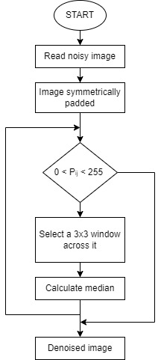

* Pi,j : It refers to the pixel value at location (i,j) of the matrix

**RESULT :**

Below are the results of the performance of the various filters mentioned in this document:

We have added 50% salt and pepper noise to the given image and performance of the filter are as follows:

|  |  |  |  |
| --- | --- | --- | --- |
|  |  |  |  |
| Original image | Noisy Image | Basic Mean Filter | Basic Median Filter |
|  |  |  |  |
| Adaptive Median Filter | Modified Decision Based Unsymmetrically Trimmed Median Filter | Adaptive Riesz Mean Filter | Different Adaptive Modified Riesz Mean Filter |
|  |  |  |  |
| Alpha Trimmed Mean Filter | Geometric Mean Filter | Modified Mean Filter | Min Filter |
|  |  |  |  |
| Max Filter | Sector Rotational Filter | Recursive Spline Interpolation Filter |  |

Below are the performance of the filters based on psnr values in graphical form:

Noise: Salt and Pepper (From 10% to 90%);

Noise: Gaussian (From 10% to 90%);

Noise: Speckle (From 10% to 90%);

Noise: Gamma (From 10% to 90%);

Noise: Rician (From 10% to 90%);

Noise: Rayleigh (From 10% to 90%):

Noise: Quantization (From 10% to 90%):

Noise: Periodic (From 10% to 90%):

CONCLUSION:

From the above shown graphs it can be concluded that most of the filters enhanced the PSNR value of the image.

Details for the specific noises are given below:

1. **Impulse noise (salt and pepper):**

|  |  |  |  |  |  |  |  |  |  |  |  |  |  |  |
| --- | --- | --- | --- | --- | --- | --- | --- | --- | --- | --- | --- | --- | --- | --- |
| **noise %** | **Noisy** | **BmeanF** | **BMF** | **AMF** | **MDBUTMF** | **ARmF** | **DAMRmF** | **ATmF** | **GmF** | **MMF** | **MinF** | **MaxF** | **SRF** | **RSIF** |
| 10 | 14.72 | 31.43 | 34.26 | 30.79 | 34.02 | 33.14 | 34.27 | 21.59 | 24.92 | 33.80 | 18.84 | 18.97 | 17.37 | 17.47 |
| 20 | 11.71 | 26.90 | 30.60 | 29.04 | 31.30 | 30.71 | 31.94 | 19.77 | 22.96 | 28.84 | 19.03 | 19.18 | 14.50 | 14.55 |
| 30 | 9.95 | 23.63 | 27.95 | 27.36 | 29.34 | 28.93 | 30.25 | 18.02 | 20.74 | 23.82 | 19.25 | 19.43 | 12.84 | 12.86 |
| 40 | 8.70 | 20.98 | 25.35 | 25.82 | 27.64 | 27.45 | 28.80 | 16.45 | 18.41 | 19.44 | 19.44 | 19.70 | 11.64 | 11.65 |
| 50 | 7.74 | 18.67 | 22.61 | 24.37 | 25.87 | 26.12 | 27.45 | 15.06 | 16.09 | 15.66 | 19.40 | 19.79 | 10.73 | 10.73 |
| 60 | 6.94 | 16.61 | 19.66 | 23.00 | 23.65 | 24.91 | 26.16 | 13.82 | 13.83 | 12.59 | 18.63 | 19.05 | 10.00 | 10.01 |
| 70 | 6.28 | 14.73 | 16.50 | 21.58 | 20.59 | 23.76 | 24.81 | 12.74 | 11.59 | 10.08 | 16.31 | 16.50 | 9.39 | 9.40 |
| 80 | 5.70 | 12.95 | 13.14 | 20.00 | 16.91 | 22.57 | 23.29 | 11.76 | 9.36 | 7.97 | 12.74 | 12.59 | 8.88 | 8.89 |
| 90 | 5.19 | 11.24 | 9.33 | 17.13 | 13.12 | 21.28 | 21.35 | 10.87 | 7.18 | 6.21 | 8.84 | 8.44 | 8.43 | 8.46 |

* Adaptive Riesz Mean filter and Different Adaptive Modified Riesz Mean filter constantly performed well in all types of noise ranges for impulse noise.
* Modified Decision Based Unsymmetric Trimmed Median filter, Adaptive Median filter, Alpha trimmed mean filter and Basic Mean Filter failed to produce good PSNR values at high ranges of noise density, but performed well in all other noise values.
* Basic Median filter , Geometric mean filter, Modified Median filter, Min/ Max filter, Sector rotation filter and Recursive spline interpolation filter were able to produce high PSNR values only at low ranges of noise density.

**Therefore, from this comparison we can conclude that *Adaptive Riesz Mean filter and Different Adaptive Modified Riesz Mean filter* are the best filters to remove Impulse noises from a given image.**

1. **Gaussian noise:**

|  |  |  |  |  |  |  |  |  |  |  |  |  |  |  |
| --- | --- | --- | --- | --- | --- | --- | --- | --- | --- | --- | --- | --- | --- | --- |
| **noise %** | **Noisy** | **BmeanF** | **BMF** | **AMF** | **MDBUTMF** | **ARmF** | **DAMRmF** | **ATmF** | **GmF** | **MMF** | **MinF** | **MaxF** | **SRF** | **RSIF** |
| 10 | 17.86 | 18.18 | 18.06 | 18.70 | 18.16 | 18.19 | 18.19 | 17.34 | 20.33 | 18.01 | 18.59 | 11.81 | 19.0 | 17.86 |
| 20 | 14.21 | 14.45 | 14.31 | 14.47 | 14.50 | 14.56 | 14.42 | 13.49 | 15.23 | 14.30 | 20.38 | 8.21 | 14.6 | 14.21 |
| 30 | 11.48 | 11.69 | 11.59 | 11.61 | 11.73 | 11.83 | 11.70 | 10.81 | 12.00 | 11.58 | 16.94 | 5.11 | 11.7 | 11.48 |
| 40 | 9.47 | 9.69 | 9.58 | 9.54 | 9.75 | 9.84 | 9.74 | 8.86 | 9.77 | 9.56 | 13.56 | 3.84 | 9.67 | 9.47 |
| 50 | 7.95 | 8.19 | 8.07 | 8.00 | 8.28 | 8.41 | 8.25 | 7.41 | 8.14 | 8.05 | 10.99 | 3.22 | 8.13 | 7.95 |
| 60 | 6.82 | 7.07 | 6.93 | 6.85 | 7.19 | 7.36 | 7.15 | 6.35 | 6.93 | 6.91 | 9.05 | 2.81 | 6.97 | 6.82 |
| 70 | 6.02 | 6.25 | 6.10 | 6.03 | 6.40 | 6.61 | 6.31 | 5.64 | 6.08 | 6.09 | 7.57 | 2.61 | 6.12 | 6.02 |
| 80 | 5.49 | 5.68 | 5.55 | 5.49 | 5.84 | 6.09 | 5.70 | 5.23 | 5.52 | 5.53 | 6.48 | 2.65 | 5.56 | 5.49 |
| 90 | 5.19 | 5.32 | 5.22 | 5.19 | 5.45 | 5.73 | 5.32 | 5.05 | 5.20 | 5.21 | 5.73 | 2.96 | 5.23 | 5.19 |

**All of the filter designed are spatial filter hence they are not very effective against gaussian noise**

**From the PSNR table, we can observe that none of the filters were able to enhance the image quality significantly and therefore we can conclude that none of the designed filter is able to denoise the image having gaussian noise.**

1. **Speckle noise:**

|  |  |  |  |  |  |  |  |  |  |  |  |  |  |  |
| --- | --- | --- | --- | --- | --- | --- | --- | --- | --- | --- | --- | --- | --- | --- |
| **noise %** | **Noisy** | **BmeanF** | **BMF** | **AMF** | **MDBUTMF** | **ARmF** | **DAMRmF** | **ATmF** | **GmF** | **MMF** | **MinF** | **MaxF** | **SRF** | **RSIF** |
| 10 | 15.97 | 15.92 | 16.05 | 17.54 | 15.31 | 15.46 | 15.43 | 22.05 | 20.50 | 16.05 | 10.89 | 13.87 | 18.0 | 15.97 |
| 20 | 13.21 | 13.03 | 13.22 | 14.80 | 12.30 | 12.48 | 12.43 | 20.44 | 17.02 | 13.25 | 8.23 | 12.43 | 15.3 | 13.21 |
| 30 | 11.58 | 11.34 | 11.57 | 13.17 | 10.53 | 10.72 | 10.67 | 19.02 | 14.17 | 11.60 | 6.58 | 11.54 | 13.7 | 11.58 |
| 40 | 10.50 | 11.02 | 11.25 | 12.25 | 10.11 | 10.36 | 10.28 | 17.93 | 13.38 | 11.27 | 6.31 | 10.90 | 12.8 | 10.50 |
| 50 | 9.85 | 11.09 | 11.30 | 11.89 | 10.09 | 10.41 | 10.29 | 17.22 | 13.73 | 11.24 | 6.51 | 10.41 | 12.2 | 9.85 |
| 60 | 9.41 | 11.12 | 11.30 | 11.68 | 10.07 | 10.45 | 10.29 | 16.69 | 13.98 | 11.14 | 6.70 | 10.01 | 11.8 | 9.41 |
| 70 | 9.08 | 11.11 | 11.26 | 11.49 | 10.01 | 10.43 | 10.24 | 16.28 | 14.12 | 10.98 | 6.84 | 9.66 | 11.5 | 9.08 |
| 80 | 8.84 | 11.12 | 11.24 | 11.37 | 10.00 | 10.46 | 10.24 | 16.00 | 14.29 | 10.84 | 6.99 | 9.39 | 11.3 | 8.84 |
| 90 | 8.63 | 11.11 | 11.19 | 11.25 | 9.96 | 10.46 | 10.20 | 15.75 | 14.37 | 10.68 | 7.12 | 9.13 | 11.2 | 8.63 |

* Alpha Trimmed mean filter and Geometric mean filter constantly performed well in all types of noise ranges for speckle noise.
* Basic Mean Filter, Adaptive Median filter, Basic Median filter Adaptive Riesz Mean filter, Different Adaptive Modified Riesz Mean filter, Sector rotation filter and Recursive spline interpolation filter failed to produce good PSNR values at high ranges of noise density, but performed relatively well in all other noise values.
* Modified Decision Based Unsymmetric Trimmed Median filter and Min/ Max filter were constantly unable to produce considerable PSNR values even at low noise density

**Therefore, we can conclude that*, Alpha Trimmed mean filter and Geometric mean filter* showed improved performance at high density noise and can be considered to remove high density speckle noises.**

1. **Gamma noise:**

|  |  |  |  |  |  |  |  |  |  |  |  |  |  |  |
| --- | --- | --- | --- | --- | --- | --- | --- | --- | --- | --- | --- | --- | --- | --- |
| **noise %** | **Noisy** | **BmeanF** | **BMF** | **AMF** | **MDBUTMF** | **ARmF** | **DAMRmF** | **ATmF** | **GmF** | **MMF** | **MinF** | **MaxF** | **SRF** | **RSIF** |
| 10 | 25.50 | 25.71 | 25.75 | 25.88 | 25.72 | 25.66 | 25.69 | 20.69 | 24.78 | 25.75 | 19.81 | 15.64 | 26.7 | 25.50 |
| 20 | 20.02 | 20.42 | 20.40 | 21.51 | 20.43 | 20.41 | 20.42 | 18.45 | 21.88 | 20.37 | 20.49 | 12.56 | 21.1 | 20.02 |
| 30 | 16.96 | 17.56 | 17.50 | 18.72 | 17.58 | 17.58 | 17.58 | 16.63 | 19.56 | 17.45 | 20.94 | 10.46 | 18.0 | 16.96 |
| 40 | 14.92 | 15.79 | 15.70 | 16.73 | 15.83 | 15.83 | 15.83 | 15.15 | 17.79 | 15.65 | 21.24 | 9.14 | 15.9 | 14.92 |
| 50 | 13.45 | 14.60 | 14.48 | 15.23 | 14.67 | 14.67 | 14.65 | 13.95 | 16.40 | 14.42 | 21.39 | 8.26 | 14.5 | 13.45 |
| 60 | 12.36 | 13.79 | 13.64 | 14.09 | 13.89 | 13.90 | 13.87 | 12.97 | 15.30 | 13.57 | 21.45 | 7.70 | 13.4 | 12.36 |
| 70 | 11.50 | 13.18 | 13.00 | 13.19 | 13.33 | 13.34 | 13.29 | 12.16 | 14.38 | 12.89 | 21.42 | 7.30 | 12.5 | 11.50 |
| 80 | 10.83 | 12.72 | 12.49 | 12.47 | 12.92 | 12.93 | 12.86 | 11.49 | 13.64 | 12.35 | 21.30 | 7.01 | 11.9 | 10.83 |
| 90 | 10.28 | 12.35 | 12.07 | 11.88 | 12.60 | 12.62 | 12.52 | 10.92 | 12.99 | 11.87 | 21.14 | 6.77 | 11.3 | 10.28 |

* Minimum filter constantly performed well in all types of noise ranges for Gamma noise.
* Basic Mean Filter, Adaptive Median filter, Basic Median filter Adaptive Riesz Mean filter, Different Adaptive Modified Riesz Mean filter, Alpha trimmed mean filter, Sector rotation filter, Recursive spline interpolation filter and Modified Decision Based Unsymmetric Trimmed Median filter failed to produce good PSNR values at high ranges of noise density, but performed relatively well in all other noise values.
* Max filter was constantly unable to produce considerable PSNR values even at low noise density

**From the comparison table we can observe that only *Minimum filter* can denoise the image containing gamma noise and therefore is an ideal option for gamma noise denoising.**

1. **Rician noise:**

|  |  |  |  |  |  |  |  |  |  |  |  |  |  |  |
| --- | --- | --- | --- | --- | --- | --- | --- | --- | --- | --- | --- | --- | --- | --- |
| **noise %** | **Noisy** | **BmeanF** | **BMF** | **AMF** | **MDBUTMF** | **ARmF** | **DAMRmF** | **ATmF** | **GmF** | **MMF** | **MinF** | **MaxF** | **SRF** | **RSIF** |
| 10 | 23.31 | 23.33 | 23.43 | 24.77 | 23.30 | 23.23 | 23.28 | 22.80 | 25.10 | 23.43 | 16.10 | 16.17 | 25.84 | 26.40 |
| 20 | 17.74 | 17.99 | 18.06 | 20.20 | 17.89 | 17.86 | 17.87 | 22.39 | 22.54 | 18.05 | 12.90 | 13.11 | 20.10 | 20.29 |
| 30 | 14.64 | 15.07 | 15.16 | 17.35 | 14.87 | 14.87 | 14.85 | 21.58 | 19.98 | 15.14 | 10.75 | 10.88 | 17.17 | 17.29 |
| 40 | 12.59 | 13.24 | 13.36 | 15.35 | 12.94 | 12.97 | 12.92 | 20.46 | 17.76 | 13.33 | 9.28 | 9.45 | 15.22 | 15.31 |
| 50 | 11.12 | 12.08 | 12.23 | 13.88 | 11.65 | 11.73 | 11.66 | 19.26 | 15.95 | 12.18 | 8.34 | 8.62 | 13.83 | 13.90 |
| 60 | 10.05 | 11.38 | 11.54 | 12.78 | 10.81 | 10.96 | 10.86 | 18.11 | 14.58 | 11.46 | 7.81 | 8.17 | 12.79 | 12.85 |
| 70 | 9.25 | 10.95 | 11.12 | 11.97 | 10.24 | 10.48 | 10.34 | 17.14 | 13.54 | 10.99 | 7.52 | 7.92 | 12.02 | 12.07 |
| 80 | 8.63 | 10.68 | 10.85 | 11.40 | 9.84 | 10.17 | 10.00 | 16.31 | 12.72 | 10.63 | 7.35 | 7.79 | 11.42 | 11.46 |
| 90 | 8.16 | 10.53 | 10.68 | 11.00 | 9.57 | 9.99 | 9.77 | 15.64 | 12.05 | 10.37 | 7.28 | 7.73 | 10.97 | 11.00 |

* Alpha trimmed mean filter and geometric mean filter constantly performed relatively well in all types of noise ranges for Rician noise.
* Basic Mean Filter, Adaptive Median filter, Basic Median filter Adaptive Riesz Mean filter, Different Adaptive Modified Riesz Mean filter, Alpha trimmed mean filter, Sector rotation filter, Recursive spline interpolation filter and Modified Decision Based Unsymmetric Trimmed Median filter failed to produce good PSNR values at high ranges of noise density, but performed relatively well in all other noise values.
* Min /Max filter was constantly unable to produce considerable PSNR values even at low noise density

**Alpha trimmed mean filter relatively denoised the image. *Geometric mean filter* was also able to recover the image to some extent. The rest of the filters did not work.**

1. **Rayleigh noise:**

|  |  |  |  |  |  |  |  |  |  |  |  |  |  |  |
| --- | --- | --- | --- | --- | --- | --- | --- | --- | --- | --- | --- | --- | --- | --- |
| **noise %** | **Noisy** | **BmeanF** | **BMF** | **AMF** | **MDBUTMF** | **ARmF** | **DAMRmF** | **ATmF** | **GmF** | **MMF** | **MinF** | **MaxF** | **SRF** | **RSIF** |
| 10 | 25.26 | 25.32 | 25.35 | 24.75 | 25.30 | 25.23 | 25.27 | 20.05 | 23.91 | 25.34 | 20.37 | 15.63 | 25.62 | 25.92 |
| 20 | 19.65 | 19.89 | 19.82 | 19.84 | 19.89 | 19.87 | 19.88 | 17.37 | 20.12 | 19.79 | 21.28 | 12.58 | 20.15 | 20.25 |
| 30 | 16.51 | 16.75 | 16.64 | 16.88 | 16.79 | 16.80 | 16.76 | 15.29 | 17.41 | 16.61 | 21.36 | 10.06 | 16.98 | 17.02 |
| 40 | 14.31 | 14.58 | 14.46 | 14.76 | 14.63 | 14.66 | 14.58 | 13.61 | 15.38 | 14.45 | 20.85 | 8.14 | 14.77 | 14.79 |
| 50 | 12.64 | 12.99 | 12.87 | 13.14 | 13.05 | 13.10 | 12.98 | 12.21 | 13.79 | 12.85 | 20.03 | 6.74 | 13.12 | 13.13 |
| 60 | 11.32 | 11.81 | 11.67 | 11.84 | 11.88 | 11.94 | 11.82 | 11.05 | 12.51 | 11.64 | 19.10 | 5.74 | 11.83 | 11.83 |
| 70 | 10.26 | 10.91 | 10.74 | 10.78 | 11.01 | 11.09 | 10.96 | 10.07 | 11.44 | 10.69 | 18.16 | 5.06 | 10.80 | 10.80 |
| 80 | 9.42 | 10.25 | 10.02 | 9.92 | 10.37 | 10.48 | 10.35 | 9.27 | 10.57 | 9.95 | 17.28 | 4.59 | 9.97 | 9.97 |
| 90 | 8.75 | 9.74 | 9.44 | 9.23 | 9.91 | 10.04 | 9.90 | 8.61 | 9.84 | 9.34 | 16.45 | 4.27 | 9.31 | 9.31 |

**All of the filter designed are spatial filter hence they are not very effective against Rayleigh noise**

**From the PSNR table, we can observe that none of the filters were able to enhance the image quality and most of the even further deteriorated the image quality and therefore we can conclude that none of the designed filter is able to denoise the image having Rayleigh noise.**

1. **Quantization noise**

|  |  |  |  |  |  |  |  |  |  |  |  |  |  |  |
| --- | --- | --- | --- | --- | --- | --- | --- | --- | --- | --- | --- | --- | --- | --- |
| **noise %** | **Noisy** | **BmeanF** | **BMF** | **AMF** | **MDBUTMF** | **ARmF** | **DAMRmF** | **ATmF** | **GmF** | **MMF** | **MinF** | **MaxF** | **SRF** | **RSIF** |
| 10 | 14.82 | 14.83 | 14.84 | 14.99 | 14.83 | 14.83 | 14.83 | 15.75 | 14.68 | 14.84 | 10.87 | 18.43 | 15.13 | 15.15 |
| 20 | 10.18 | 10.26 | 10.25 | 10.34 | 10.25 | 10.26 | 10.26 | 10.81 | 10.09 | 10.25 | 7.39 | 14.19 | 10.38 | 10.38 |
| 30 | 8.59 | 8.75 | 8.73 | 8.76 | 8.75 | 8.76 | 8.76 | 9.13 | 8.50 | 8.72 | 6.17 | 12.56 | 8.79 | 8.80 |
| 40 | 8.10 | 8.41 | 8.36 | 8.32 | 8.41 | 8.42 | 8.42 | 8.74 | 8.07 | 8.34 | 5.74 | 12.59 | 8.38 | 8.38 |
| 50 | 7.30 | 7.68 | 7.61 | 7.47 | 7.69 | 7.71 | 7.71 | 7.79 | 7.31 | 7.58 | 5.39 | 11.39 | 7.54 | 7.54 |
| 60 | 7.03 | 7.53 | 7.43 | 7.22 | 7.55 | 7.58 | 7.57 | 7.54 | 7.14 | 7.39 | 5.30 | 11.24 | 7.31 | 7.32 |
| 70 | 6.74 | 7.32 | 7.19 | 6.93 | 7.34 | 7.38 | 7.37 | 7.22 | 6.92 | 7.13 | 5.22 | 10.86 | 7.04 | 7.04 |
| 80 | 6.46 | 7.06 | 6.91 | 6.62 | 7.09 | 7.14 | 7.13 | 6.87 | 6.68 | 6.84 | 5.15 | 10.32 | 6.74 | 6.74 |
| 90 | 6.29 | 6.92 | 6.75 | 6.44 | 6.96 | 7.01 | 7.01 | 6.67 | 6.56 | 6.67 | 5.12 | 10.04 | 6.57 | 6.58 |

* Maximum filter was able to enhance the image quality up to some extent.
* All the other filter were unable to enhance the image quality rather most of them even further deteriorated the image.

**From the PSNR table, we can observe that only Maximum filters was able to enhance the image quality and rest of the filter deteriorated the image quality and therefore we can conclude that only *‘Maximum filter’* of the designed filter can be used to denoise the image having Rayleigh noise.**

1. **Periodic noise:**

|  |  |  |  |  |  |  |  |  |  |  |  |  |  |  |
| --- | --- | --- | --- | --- | --- | --- | --- | --- | --- | --- | --- | --- | --- | --- |
| **noise %** | **Noisy** | **BmeanF** | **BMF** | **AMF** | **MDBUTMF** | **ARmF** | **DAMRmF** | **ATmF** | **GmF** | **MMF** | **MinF** | **MaxF** | **SRF** | **RSIF** |
| 10 | 23.17 | 23.13 | 23.16 | 22.69 | 23.06 | 22.99 | 23.05 | 20.19 | 21.49 | 23.16 | 16.46 | 14.67 | 22.70 | 23.09 |
| 20 | 17.58 | 17.63 | 17.59 | 17.50 | 17.61 | 17.68 | 17.62 | 16.69 | 17.11 | 17.59 | 13.51 | 10.68 | 17.55 | 17.68 |
| 30 | 14.36 | 14.45 | 14.38 | 14.37 | 14.45 | 14.59 | 14.47 | 13.98 | 14.23 | 14.38 | 11.16 | 9.14 | 14.44 | 14.49 |
| 40 | 12.20 | 12.30 | 12.22 | 12.25 | 12.32 | 12.54 | 12.35 | 12.01 | 12.20 | 12.22 | 9.46 | 8.09 | 12.33 | 12.34 |
| 50 | 10.59 | 10.69 | 10.61 | 10.66 | 10.74 | 11.04 | 10.76 | 10.50 | 10.66 | 10.60 | 8.25 | 7.21 | 10.73 | 10.71 |
| 60 | 9.36 | 9.47 | 9.38 | 9.45 | 9.52 | 9.91 | 9.54 | 9.34 | 9.47 | 9.37 | 7.34 | 6.52 | 9.51 | 9.47 |
| 70 | 8.40 | 8.51 | 8.41 | 8.49 | 8.56 | 9.08 | 8.58 | 8.43 | 8.53 | 8.41 | 6.66 | 5.97 | 8.57 | 8.51 |
| 80 | 7.64 | 7.75 | 7.65 | 7.74 | 7.81 | 8.48 | 7.81 | 7.72 | 7.77 | 7.65 | 6.11 | 5.60 | 7.82 | 7.75 |
| 90 | 7.05 | 7.17 | 7.06 | 7.18 | 7.23 | 8.10 | 7.22 | 7.18 | 7.19 | 7.06 | 5.75 | 5.36 | 7.30 | 7.17 |

**From the PSNR table, we can observe that none of the filters were able to enhance the image quality and a few of the even further deteriorated the image quality and therefore we can conclude that none of the designed filter is able to denoise the image having Periodic noise.**

1. **Poisson noise:**

|  |  |  |  |  |  |  |  |  |  |  |  |  |  |  |
| --- | --- | --- | --- | --- | --- | --- | --- | --- | --- | --- | --- | --- | --- | --- |
| **noise %** | **Noisy** | **BmeanF** | **BMF** | **AMF** | **MDBUTMF** | **ARmF** | **DAMRmF** | **ATmF** | **GmF** | **MMF** | **MinF** | **MaxF** | **SRF** | **RSIF** |
| 10 | 27.11 | 26.99 | 27.17 | 27.48 | 26.95 | 26.80 | 26.90 | 22.94 | 25.79 | 27.17 | 17.32 | 17.46 | 29.17 | 30.68 |

* The addition of poisson noise in the image nearly had no impact on the image quality as the PSNR of noisy image is about 27.11.
* Min/Max filter degraded the image quality significantly a deteriorated image.
* All the other filters gave a PSNR value nearly equal to the noisy PSNR value.
* Recursive spline interpolation filter and sector rotation filter marginally enhanced the PSNR value

**We can therefore conclude that *Sector Rotation filter and Recursive spline interpolation filter* can be used to de-noise the image having passion noise.**

**REFERENCE: -**

* Yuan-Bin Wang, Hai-Long Huang 2021 Image Denoising Based on Adaptive Sector Rotation Median Filter
* S. Zhang, X. Li and C. Zhang, "Modified Adaptive Median Filtering," 2018 International Conference on Intelligent Transportation, Big Data & Smart City (ICITBS), Xiamen, China, 2018, pp. 262-265.
* Enginoğlu, Serdar & Erkan, Uğur & Memiş, Samet. (2019). Pixel Similarity-Based Adaptive Riesz Mean Filter for Salt-and-Pepper Noise Removal. Multimedia Tools and Applications. 78. 35401-35418. 10.1007/s11042-019-08110-1.
* Memiş, S. and Erkan, U., 2021. Different adaptive modified Riesz mean filter for high-density salt-and-pepper noise removal in grayscale images. Avrupa Bilim ve Teknoloji Dergisi, (23), pp.359-367.
* R. Oten and R. J. P. de Figueiredo, "Alpha-trimmed mean filters under deviations from assumed noise model," in IEEE Transactions on Image Processing, vol. 13, no. 5, pp. 627-639, May 2004.
* B. Navya, J. Sridevi and K. Vasanth, "Geometric Mean Filter” 2022 3rd International Conference on Smart Electronics and Communication (ICOSEC), Trichy, India, 2022, pp. 1095-1102.